Bangladesh Digital Storytelling Workshop
Developing technical skills in photography, videography, and storytelling

Dhaka, Bangladesh: October 2 - 7, 2018

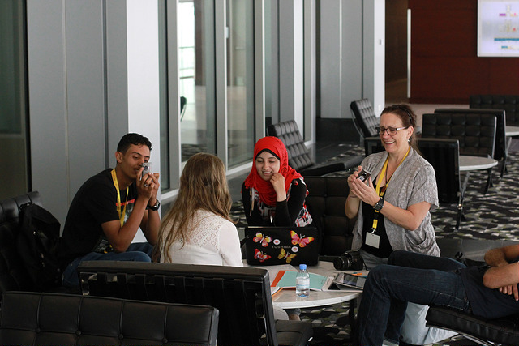

APPLICATION
Due date: July 11 at 5PM EDT
Please complete the entire application, including essay questions, and return it by July 11th at 5 PM EDT! Please email your application to your country coordinator.

DIGITAL STORYTELLING WORKSHOP

The Digital Storytelling workshop is a four-day, intensive training workshop, which requires your active participation and commitment to becoming a local alumni-training resource!

The Digital Storytelling Workshop is hands-on, and enhances and expands participants’ technical skills in video and photography. In today’s multimedia environment, activism and community service require a range of communication and media skills. The workshop will explore time-tested storytelling techniques, focusing on creating accessible messages for both local and international audiences

Objectives: At the close of this Digital Storytelling Workshop, participants will be able to:
- Create multimedia profiles of alumni group members;
- Work in teams to produce short films and multimedia blog posts about community leaders/alumni and their experiences with digital collaboration;
- Digitally distribute media through a variety of online platforms and outreach;
- Develop plans to share skills learned and continue digital networking/outreach.
- Capture impact of YES alumni projects and share with a wider audience.

Eligibility:
- Successful completion of the YES program in or before 2017 (students returning from the program in 2018 are not eligible to apply).
- Demonstrated participation in alumni activities and community service.

Criteria:
- Demonstrated commitment to community service;
- Positive and enthusiastic attitude;
- Demonstrated ability to be flexible and responsible;
- Demonstrated leadership skills or potential;
- Demonstrated commitment to the growth and leadership development of your country’s alumni association and the sustainability of alumni networks in your region;
- Open to giving/receiving feedback;
- Ability to collaborate with others outside the YES networks and enthusiasm for working as part of a team;
- Ability to handle challenging situations;
- Ability to communicate effectively.

Requirements:
- Must be available to attend the entire event (October 2 - 7; attendees are expected to arrive the morning of October 2nd and depart in the afternoon of October 7th);
- Must commit to training others in your community and promoting alumni leadership development upon returning home; at least one local training must be held within 4 months of returning from the workshop;
- Must create and submit at least one (1) digital storytelling product within four (4) months of returning from the workshop.
If you are selected, please note the following:
- All travel and accommodation expenses, including the cost of round-trip international travel, visa, accommodation and meals, are covered.
- You are responsible for any personal costs, such as souvenirs, snacks, or personal travel.
- You are responsible for submitting your own visa application. A letter of support for your visa will be issued, but we cannot guarantee that the visa will be granted. Please contact your YES country coordinator for any assistance.

PART 1 *Name EXACTLY as written in your passport**Very Important!!

First:

Middle:

Last:

Gender:
□ Female
□ Male

Current Postal address (city, state/region, postal code):

Home country:

Country of current residence:

Home phone number:

Phone number:

E-mail address:

U.S. City and State in which you were hosted:

Years you were on the YES program:

Have you attended an alumni event abroad in the past year?
□ YES
□ NO
If yes, what was the event?

PART 2: Personal Essays

Please respond to the following questions (in no more than 400 words per question):

1. What do you hope to learn from the Digital Storytelling Workshop and how would you put those skills to use in your community?

2. Describe one story in your community (negative or positive) that you would like to highlight using Digital Storytelling tools?

3. Please describe any experience you have with social media, storytelling, journalism, filmmaking, photography, etc.
4. Give specific examples of alumni or service activities in which you have participated and/or played a leading role.

PART 3: YES Alumni Commitment

Please sign the following before submitting your application:

I have read and understand the information above and am ready, willing and able to take on the responsibilities of alumni leadership and willing to undertake the responsibilities of being a Digital Storyteller for the YES community, a leader, and a trainer.

Signature: Date:

Please complete the entire application, including essay questions, and return it to your Country Coordinator by July 11th at 5 PM EDT!

