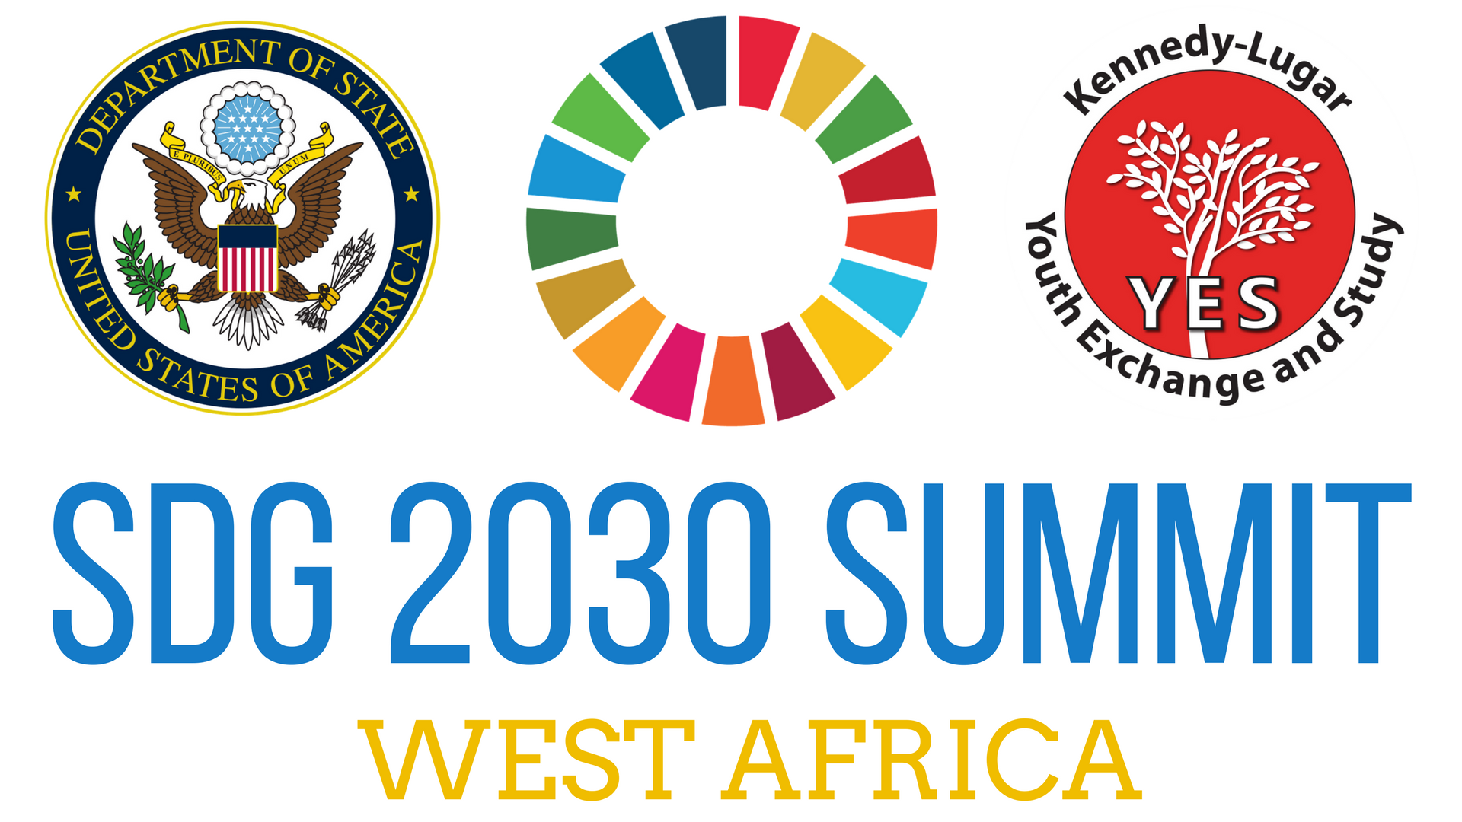
YES SDG 2030 Summit for West African Region
December 19 - 21, 2017 • Accra, Ghana

The UN Sustainable Development Goals (SDGs) are set to be achieved by 2030 through the efforts of change agents around the world. Now, more than ever, organizations and affiliates of the UN are focusing more on the SDGs, promoting the vision of the featured 17 goals while encouraging the world to develop SDG- oriented projects and initiatives. As service-oriented youth of action, YES alumni have proven to be change agents who are fully committed to the global solutions promoted by each SDG.

Hosted by the Kennedy-Lugar Youth Exchange and Study (YES) program, the SDG 2030 three-day summit for the West African Region will officially introduce YES alumni in the West African Region to the SDGs, help alumni develop innovative ways to provide solutions for societal problems using the SDGs, and teach participants how to effectively influence their community leaders to support their initiatives. The summit is equipped with a variety of session topics including project planning, communications, and leadership. As a platform for the youth, SDG 2030 also serves as an inclusive conversation for YES alumni to address issues affecting their regional communities while discussing solutions. The workshop will be held in Accra, Ghana from December 19-21, 2017. Participants will arrive December 18th and depart December 22nd.

Participants will be able to effectively identify and communicate the UN’s Sustainable Development Goals, plan, organize, and execute projects that fulfill an SDG goal(s), gain increased skills in communicating ideas and plans of action to government officials and community leaders, learn to build international awareness around their global goal projects, and become motivated and prepared to execute strategic projects to influence change in their regional communities.

Transportation to and from Ghana, visa fees, housing, and meal costs will be provided to all alumni participants. Additional travel or spending money is the responsibility of the participant. The alumnus/alumna that best fits the following criteria should be selected to serve as your country’s representative.

Eligible Candidates:
• Did not attend an international alumni in-person workshop in the last year
• Demonstrates initiative, motivation, and interest for planning, organizing, and executing projects related to the SDGs
• Interest in identifying and developing innovative solutions to address problems in the community
• Available to travel to Ghana for the workshop dates listed (passport valid for 6 months after entry and appropriate visa requirements)
• Must have completed their YES program year in 2016 or before
• Must complete pre-workshop assignments
• Committed to fulfilling the required follow-on tasks within the three month period
• Interested in further developing their knowledge and application of the UN SDGs

Each alumni representative chosen to attend the training should complete the following form and submit to the country office along with a copy of the individual’s passport no later than November 10, 2017.

YES Alumni Association Leader Training Application
December 19 - 21, 2017 • Accra, Ghana

Name:

Gender: YES Program End Year:

Country: Current city:

Phone number: Email:

1. Describe your previous experience with leading or helping to implement a service project in your community.

2. What do you know about the UN Sustainable Development Goals (SDGs)?
(Your level of knowledge about the SDGs will not affect your selection.)

3. What role do you play or have you played in your local Alumni Association?

4. Briefly write about a specific issue in your community that you would like to address. How might you use the skills gained from this workshop to address the issue?

5. If given an opportunity to attend the SDG 2030 Summit for West Africa, what SDG would you be interested in fulfilling and why?

** Please submit with a copy of your passport no later than November 10, 2017.**

