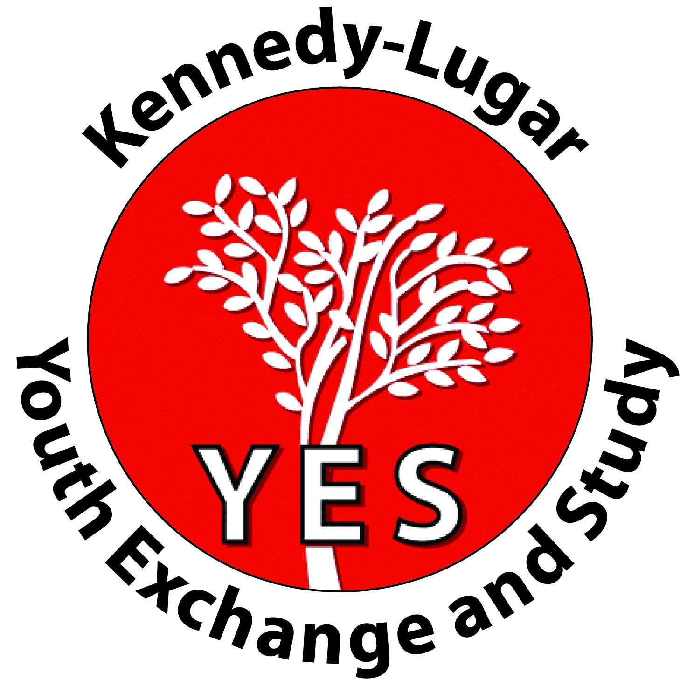
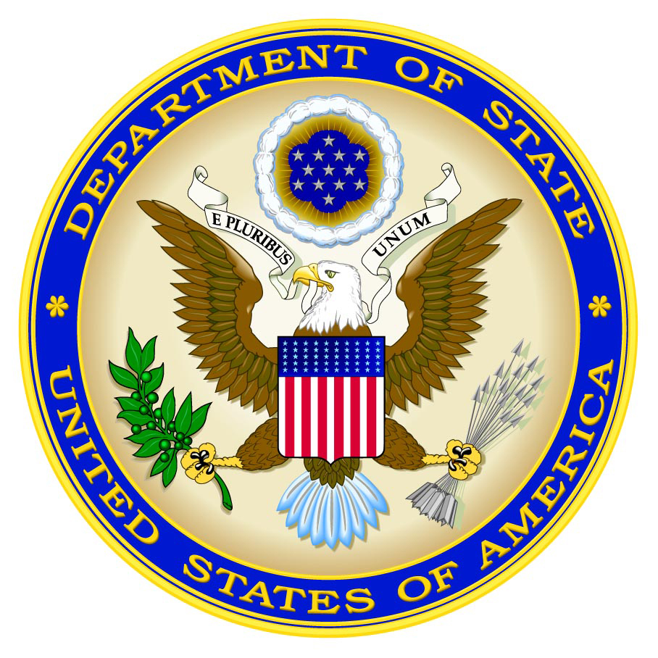
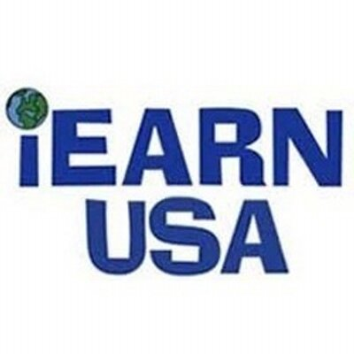
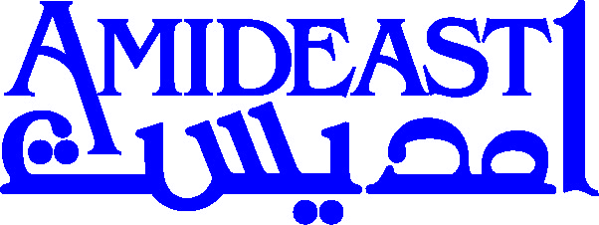
YES ALUMNI WORKSHOP APPLICATION

YES GPS: Gender Parity Specialists

From March 1 – 4, 2019, AMIDEAST and iEARN will host a global YES alumni workshop focused on the promotion of gender parity. The event will target YES alumni who currently or previously have been involved in significant efforts towards gender equality, empowering women and girls, engaging men and boys in gender related projects, and/or general development projects with a significant gender focus.

YESDP will provide participants with the necessary practical and theoretical knowledge to improve the outcomes of gender parity volunteer projects, professional work, and/or academic pursuits to encourage more widespread, high quality understanding of gender in YES alumni programming overall.

Training will center on the mechanisms behind gender parity, project management, possibilities for incorporating gender parity into non-gender related projects, and practical uses for gender empowerment tools in the participants’ home communities. Professionals – potentially including expert YES alumni - will provide the training, and participants will prepare project proposals for review prior to departure.

A total of 15 participants will be invited. Preference will be given to those who have demonstrated leadership skills, current or recent gender parity projects that fit within the workshop theme, a strong and dedicated commitment to development objectives, and an innovative vision that builds upon sustainable improvements in gendered outcomes.

Workshop Objectives:
By the completion of this workshop, participants will:
- Have a deeper understanding of gender parity;
- Use their experiences coupled with new project management skills to implement projects and programs that offer long-term benefits to societies;
- Inspire others in the YES alumni community to incorporate a gender focus into development projects in their local contexts.

Eligibility:
YES alumni from all cohorts and program countries are welcome to apply. Finalists must be available, able, and willing to travel to Lebanon from March 1 – 4, 2019. Alumni with disabilities are encouraged to apply. Special consideration will be given to applicants with a strong background in gender topics, demonstrated commitment to community development, and genuine motivation to carry out projects in the near future.

If you would like to be considered for this opportunity, please complete the form below and submit it to your local YES staff along with a copy of your passport copy and resume/CV by November 5, 2018.

If you have questions, contact your local YES staff or email rmarkowitz@amideast.org.

YESGPS APPLICATION

Family/Last Name: Click here to enter text. YES Recruiting Country: Click here to enter text.
First Name: Click here to enter text. YES Program End Year: Click here to enter text.
Gender*: Click here to enter text. YES Placement Organization: Click here to enter text.
YES Host City/State: Click here to enter text. Email: Click here to enter text.
Current City/Country: Click here to enter text.

Please share your current job title and employer or field of study/university: Click here to enter text.

- Are you currently or previously involved in gender related volunteering, work, or academic pursuits? List and/or explain briefly.
Click here to enter text.

- Describe one experience you had while you were a YES student that was meaningful to you. What did you learn and/or how did that experience impact you later in life? Responses related to gender parity will receive special consideration.
Click here to enter text.

- Why are you most interested in attending YES GPS? What do you hope to gain from this workshop?
Click here to enter text.

- Summarize an idea or plans you have already begun to help lead or run a project with a significant gender component in the coming five years. What was/will be your role and why is this project important to you?
Click here to enter text.

- Are there any specific topics you would like to be included at YESGPS? Are there topics you think you could facilitate, present on, or lead?
Click here to enter text.

*Applicants of ALL gender identities – not limited to women - will be considered for this workshop.
Submit this application, a copy of your passport, and CV to YES staff by November 5, 2018.
Questions? Email rmarkowitz@amideast.org

