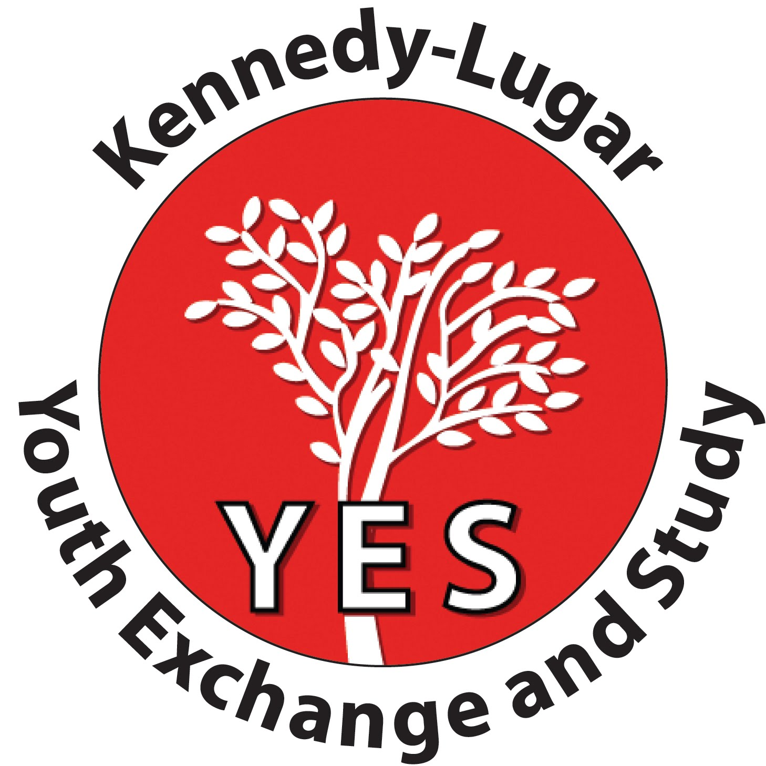
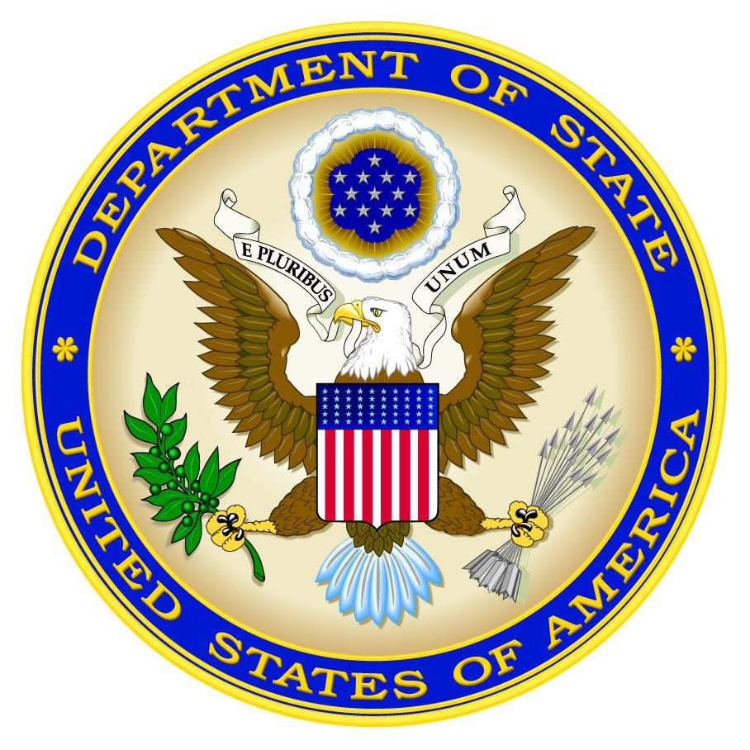
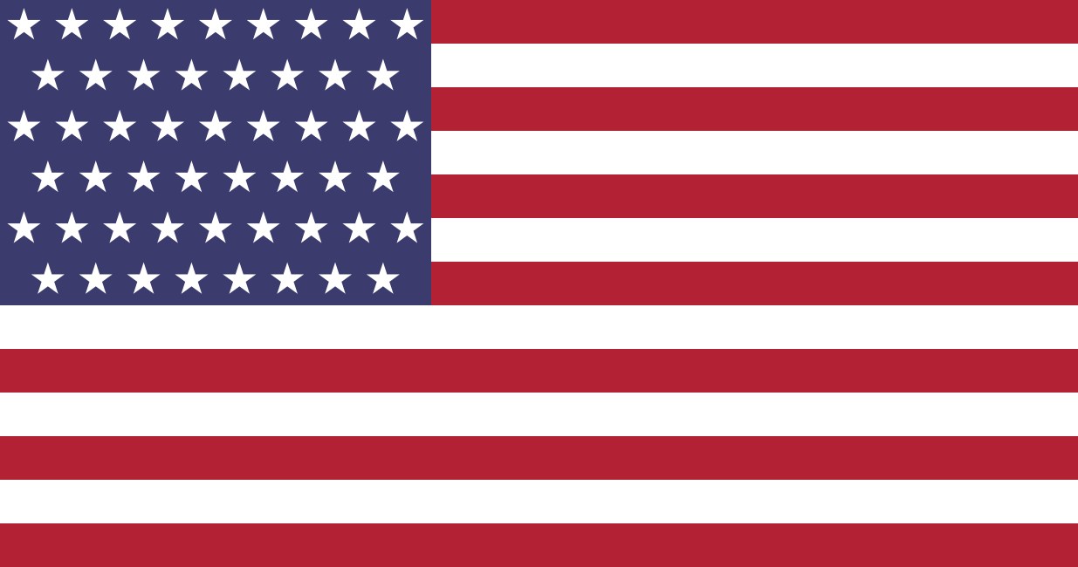
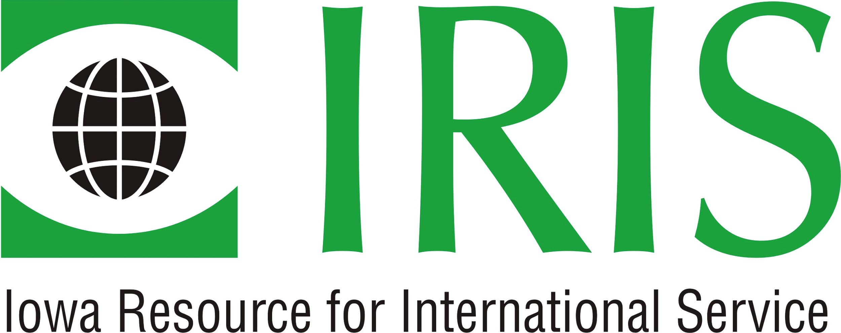
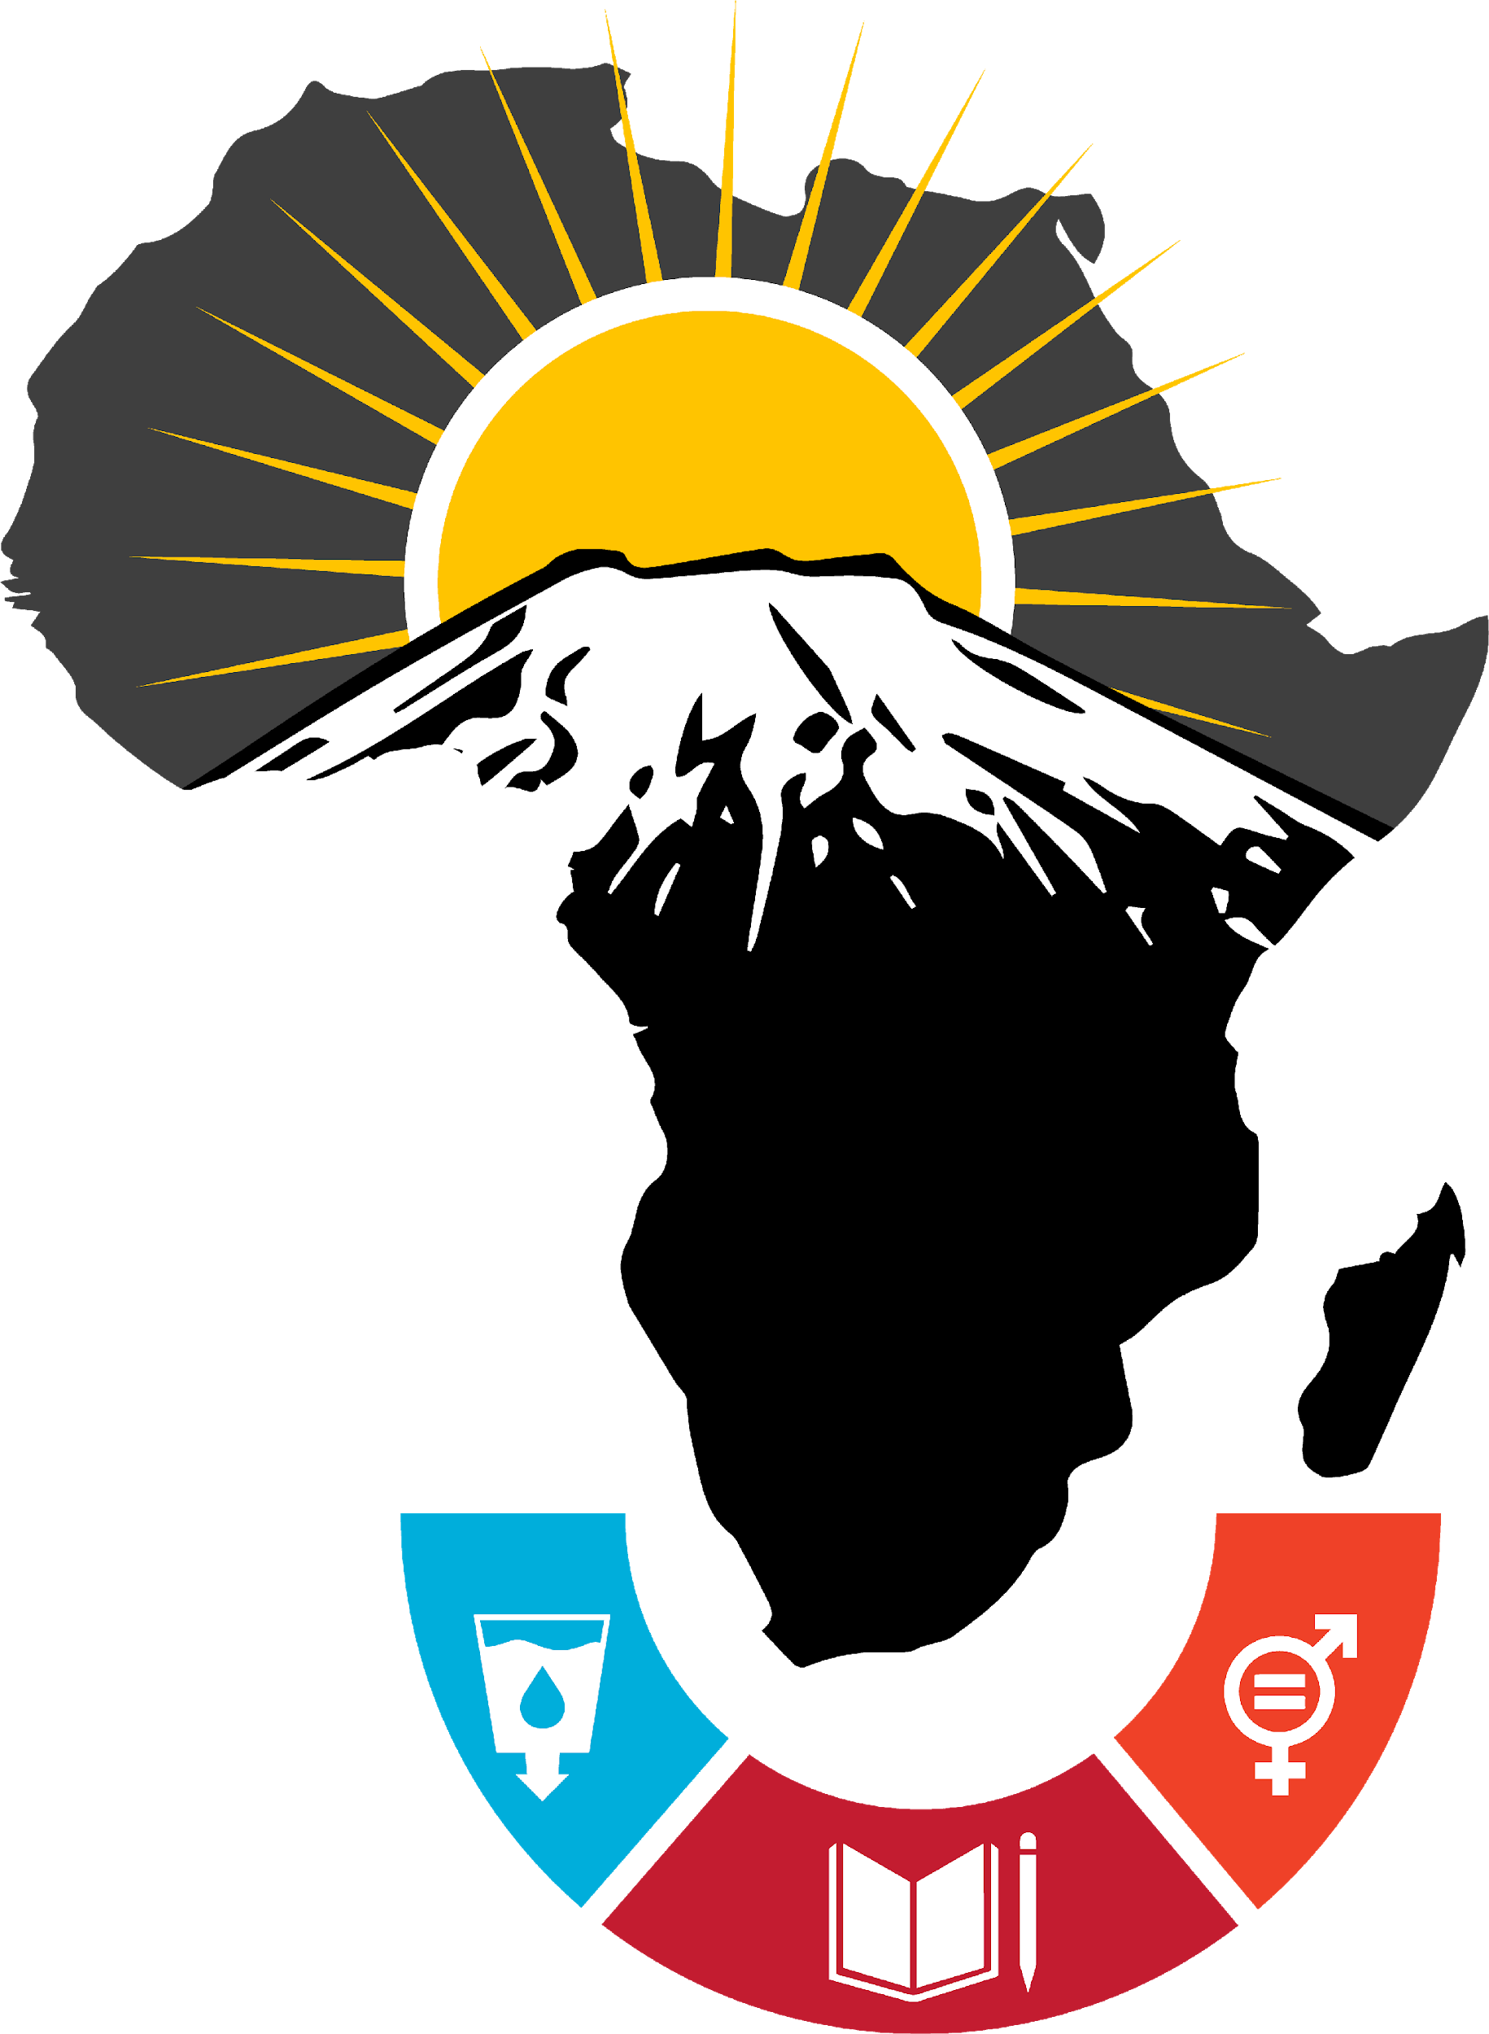

BEYOND YES SUMMIT – AFRICA

From April 20-24 2020, IRIS will host a regional summit in Arusha, Tanzania that focuses on the promotion of, and activity development around, the United Nations Sustainable Development Goals (SDGs) as related to the African continent. The event will be targeted toward YES alumni who currently hold or are actively working towards positions of leadership and authority in their respective countries. The event’s aim is to charge the alumni with stepping further into their roles as YES global ambassadors, serving as change agents throughout Africa.

The summit will be a four-day event focusing on three specific SDGs:
- Quality Education
- Clean Water and Sanitation
- Gender Equality

Training will focus on social advocacy, entrepreneurship, project management, and innovation within sustainable development practices. Content will be developed and presented by professionals within and outside of the YES consortium. A speaker series and panel discussions by experts – including YES alumni - will be coordinated to provide additional content and further understanding around the main themes outlined. Participants will work to develop projects for implementation.

Up to 2 alumni will be selected from African YES countries (Cameroon, Egypt, Ghana, Kenya, Liberia, Libya, Mali, Morocco, Mozambique, Nigeria, Senegal, Sierra Leone, South Africa, Tanzania, and Tunisia) for a total of 30 participants to attend the workshop. Preference will be given to alumni who have demonstrated leadership skills, academic or professional experiences in quality education, water sanitation and gender parity and an innovative vision that builds upon sustainable development in Africa.

Workshop Objectives:
By the completion of this workshop, participants will:
- Have a deeper understanding of the effort it takes to develop and implement projects that center on the UN Sustainable Development Goals;
- Use their leadership skills, professional portfolios, and supplemental tools to implement more effective, impactful, and sustainable projects across YES program countries in Africa; and,
- Inspire younger generations of YES alumni to become active global ambassadors, developing activities centered on the themes outlined above.

Eligibility:
YES alumni from African countries, including those with disabilities, are eligible to apply. Finalists must be available and willing to travel to Arusha, Tanzania from April 20-24 and will need to show proof of Yellow Fever vaccination prior to travelling. Special consideration will be given to applicants who have demonstrated a strong commitment to community development and genuine motivation to carry out projects in the near future.

If you would like to be considered for this opportunity, please complete the form below and submit it to your local YES staff along with a copy of your passport copy, and resume/CV by January 10, 2020

If you have questions, contact your local YES staff or email cel@iris-center.org

BEYOND YES SUMMIT – AFRICA APPLICATION

Family/Last Name: Click here to enter text. YES Recruiting Country: Click here to enter text.
First Name: Click here to enter text. YES Program End Year: Click here to enter text.
Gender*: Click here to enter text. YES Placement Organization: Click here to enter text.
YES Host City/State: Click here to enter text. Email: Click here to enter text.
Current City/Country: Click here to enter text. WhatsApp Phone Number: Click here to enter text.

Please share your current job title and employer or field of study/university: Click here to enter text.

- What innovative project have you done in your community that was successful and impactful that you want to share with your peers? (especially related to gender equality, water sanitation and quality education).
Click here to enter text.

- Which one of the aforementioned three UN Sustainable Development Goals are you most passionate about and why?
Click here to enter text.

- Why are you most interested in attending the Beyond YES Summit – Africa Workshop? What do you hope to gain from this workshop?
Click here to enter text.

- Please share the most impactful community project related to the selected UN Sustainable Development Goals you would do if you had unlimited resources. Think outside of the box, innovative and impactful ideas will be given a special consideration.
Click here to enter text.

- Are there any specific topics you would like to be included at Beyond YES Summit - Africa? Are there topics you think you could facilitate, present on, or lead?
Click here to enter text. Click here to enter text.

Submit this application, a copy of your passport, and CV to YES staff by January 10, 2020
Questions? Email cel@iris-center

