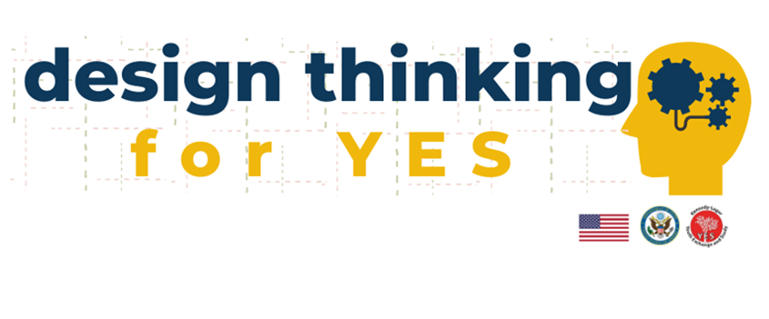



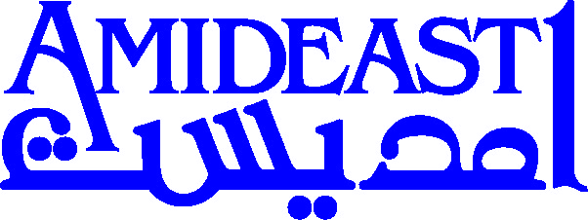

**YES ALUMNI WORKSHOP APPLICATION**

For nine weeks from October 12 – December 8, 2020, iEARN-USA and AMIDEAST will offer YES alumni from around the world a series of online trainings to enhance and expand skills and knowledge in strategic problem solving, solutions-based approaches, creative project ideation, and cross-cultural collaboration. Participants will gain design thinking expertise to improve the impact of global YES alumni projects.

Design thinking is a process for problem solving that encourages using creative skills to address a variety of challenges. This workshop will train YES alumni to think strategically and creatively about the issues they face in their communities. Content will be developed in collaboration with a design thinking trainer using interactive online modules. Workshop sessions will focus on leadership mindset, problem solving, innovation, brainstorming, and collaboration and will especially focus on the growth of YES alumni projects and associations.

Design Thinking for YES will take place over nine weeks total. The first six weeks will be the most intensive, including mandatory weekly online instruction. Although alumni will only meet once per week, they will remain connected with one another through virtual creative spaces. Between sessions, alumni will complete assignments and build a project proposal using a design thinking approach. After the weekly sessions for six weeks, participants will have optional individualized mini-coaching sessions for three weeks to finish developing a project proposal that outlines an innovative, solution-based project that addresses a need in their community. Participants will be strongly encouraged to begin implementation of their project during the workshop if feasible.

**Eligibility:**

YES alumni from all cohorts and program countries are welcome to apply. Finalists must be available, able, and willing to participate in the full nine weeks of online training, including one live session per week and ongoing interaction in virtual spaces from October 12 – December 8, 2020. Alumni with disabilities are encouraged to apply and accommodations will be available. Special consideration will be given to applicants with a strong background in project development and management who are interested in expanding their abilities to create meaningful interventions and/or to grow and improve their communities and YES alumni associations. Participants must demonstrate a genuine motivation to carry out projects in the near future.

If you would like to be considered for this opportunity, please complete the form below and submit it to your local YES staff along with a copy of your resume/CV **by September 14, 2020.**

Questions? Contact your local YES staff or email rmarkowitz@amideast.org.

**DESIGN THINKING FOR YES WORKSHOP APPLICATION**

**Family/Last Name:** Click here to enter text. **YES Recruiting Country:** Click here to enter text.

**First Name:** Click here to enter text. **YES Program End Year:** Click here to enter text.

**Gender:** Click here to enter text. **YES Placement Organization:** Click here to enter text.

**YES Host City/State:** Click here to enter text. **Email:** Click here to enter text.

**Current City/Country:** Click here to enter text. **WhatsApp phone #:** Click here to enter text.

**Please share your current job title and employer or field of study/university:** Click here to enter text.

1. **Describe a time when you needed to develop a project or program from beginning to end, either individually or as part of team. What worked well, and/or what were the biggest challenges? What did you learn and/or how did that experience impact your performance in other projects or programs later?** Please limit your response to maximum 8 sentences.

Click here to enter text.

1. **Identify a need in your community. How did you identify this need? How does your community prefer to address it?**

Click here to enter text.

1. **What topics or fields of study/work are you most passionate about?** Tell us about your interests in 2 – 5 sentences.

Click here to enter text.

1. **Have you previously received any training in Design Thinking? If so, please explain. If not, please tell us why you are excited to attend Design Thinking for YES. What do you hope to gain from this workshop?**

Click here to enter text.

**Submit this application and CV to your local YES staff by Sept 14, 2020.**

Questions? Email rmarkowitz@amideast.org