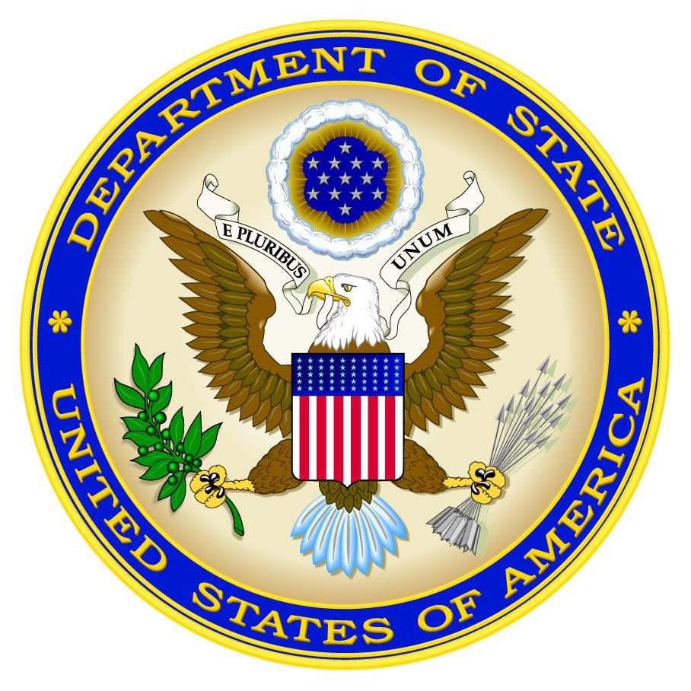
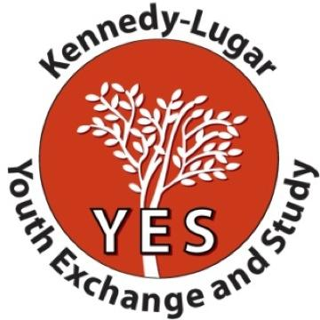

YES Inclusivity Workshop
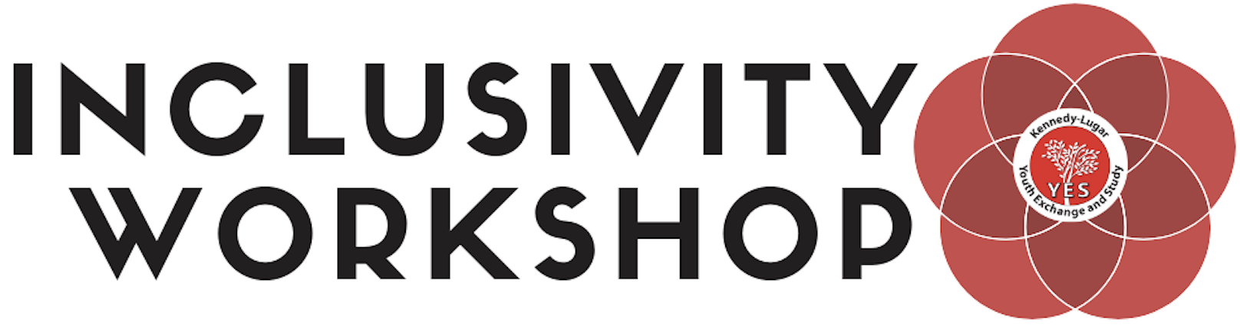

Accra, Ghana - October 10-15, 2019

APPLICATION
Due date: July 29, 2019

Please complete the entire application, including essay questions, and return it by July 29, 2019! Please email your application to your country coordinator.

INCLUSIVITY WORKSHOP

The Inclusivity Workshop is a four-day workshop from October 10 - 15, 2019 for YES alumni with disabilities and allies to strengthen skills and develop resources for making the YES program more inclusive.

The goals of the Inclusivity Workshop are twofold; 1) gather passionate alumni for a solutions-oriented and working format style workshop to develop resources and ideas to advance YES program inclusivity efforts and 2) attend skill-building sessions to strengthen advocacy, teamwork, and leadership skills while networking with YES alumni from other countries with similar passions and experience. Participants can expect to work collaboratively to create deliverables, such as customizable toolkits, to make the YES program more inclusive in recruitment, re-entry into home country, and alumni activities for YES alumni with disabilities. Participants can also expect to leave the workshop with stronger skills and YES alumni networks to advocate for and raise awareness of disability rights, laws, and resources in their communities.

Objectives - At the end of the workshop, alumni will be able to:
- Present their toolkits developed during the workshop for use in YES program recruitment, re-entry, and alumni activities;
- Inspire and motivate other alumni in their YES alumni networks to become involved in projects related to disability awareness and rights;
- Facilitate and manage an alumni with disabilities council or resource page.

Eligibility
- Successful completion of the YES program;
- Dedicated to advocacy and support for persons with disabilities;
- Demonstrated participation in alumni activities and community service;
- Did not attend an international alumni in-person workshop in the last year;
- Available to travel to Ghana for the workshop dates listed (passport valid for 6 months after entry and appropriate visa requirements);
- Must complete pre-workshop assignments;
- Committed to fulfilling the required follow-on tasks including but not limited to sharing updates, follow-up projects, and in-country YES recruitment activities.

Criteria
- Positive and enthusiastic attitude;
- Demonstrated ability to be flexible and responsible;
- Demonstrated leadership skills or potential;
- Demonstrated commitment to the growth and leadership development of your country’s alumni network and the inclusivity of alumni networks in your region;
- Open to giving/receiving feedback;
- Ability to collaborate with others as part of a team.

Requirements
- Must be available to attend the entire event from: arriving in Accra, Ghana by noon on October 10 to departing after 2pm on October 15
- Must commit to training alumni network and promoting disability awareness upon returning home; at least one local training/workshop/project with alumni network must be held within 4 months of returning from the workshop.

If you are selected, please note the following:
- All travel and accommodation expenses, including the cost of round-trip international travel, visa, accommodation and meals, and accommodations for disabilities will be covered.
- You are responsible for any personal costs, such as souvenirs, snacks, or personal travel.
- You are responsible for submitting your own visa application. A letter of support for your visa will be issued, but we cannot guarantee that the visa will be granted. Please contact your YES country coordinator for any assistance.

PART 1 *Name EXACTLY as written in your passport*Very important!

First:

Middle:

Last:

Gender:
□ Female
□ Male

Current city and country:

Home country:

Country of current residence:

Mobile/Whatsapp number:

E-mail address:

U.S. City and State in which you were hosted:

Years you were on the YES program:

Placement organization:

Have you attended an alumni event abroad in the past year?
□ YES
□ NO
If yes, what was the event?

PART 2: Personal Essays

Please respond to the following questions (in approximately 400 words per question):

1. Describe any work or projects you have done with persons with disabilities.

2. Why are you interested in attending the YES Inclusivity Workshop? What skills, knowledge, and/or project ideas will you bring to the workshop? What do you hope to gain from this opportunity?

3. What are three goals you have accomplished with the YES program? How has the YES program impacted you as an alumnus/a?

4. What are your ideas to make the YES program more inclusive in recruitment/promotions, on-program, and in alumni activities? How do you see yourself improving any of these processes?

PART 3: YES Alumni Commitment

Please sign the following before submitting your application:

I have read and understand the information above and am ready, willing, and able to take on the role of leadership for alumni with disabilities and committed to undertaking the responsibilities of an active participant in the YES Inclusivity Workshop.

Signature: Date:

Please complete the entire application, including essay question, and return it to your Country Coordinator with a copy of your passport by July 29th!

