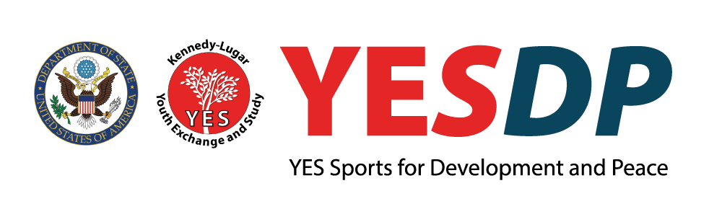
YES ALUMNI WORKSHOP APPLICATION

In April 2018, AMIDEAST will host a global YES alumni workshop focused on the promotion of Sports for Development and Peace (SDP). The event will target YES alumni who currently or previously have used SDP in development projects to provide further education on the broad uses for SDP and to help them create more impactful and sustainable projects.

YESDP will provide participants with the necessary practical and theoretical knowledge to improve the outcomes of their projects and to encourage more widespread, high quality use of SDP in YES alumni programming overall. Sports are already used for cultural exchange and community development in and out of the YES community; this workshop will improve the quality and quantity of SDP projects.

Training will center on the mechanisms behind SDP, SDP project management, mapping of SDP actors, and practical uses for SDP in the participants’ home communities. Professionals – potentially including expert YES alumni - will provide the training, and participants will prepare SDP project proposals for review prior to departure.

A total of 30 participants will be invited. Preference will be given to those who have demonstrated leadership skills, current or recent projects that fit within the SDP theme, a strong and dedicated commitment to development objectives, and an innovative vision that builds upon sustainable development of SDP.

Workshop Objectives:
By the completion of this workshop, participants will:
- Have a deeper understanding of the SDP landscape;
- Use their experiences coupled with new SDP related project management skills to implement SDP projects and programs that offer long-term benefits to societies;
- Inspire others in the YES alumni community to use sports and/or play effectively for development objectives in their local contexts.

Eligibility:
YES alumni from all cohorts and program countries are welcome to apply. Finalists must be available and willing to travel to Kuwait for four days in April 2018, exact dates TBD. Special consideration will be given to applicants with a background in sports and/or development, demonstrated commitment to community development, and genuine motivation to carry out SDP projects in the near future.

Candidates should complete the form below and submit it to their local YES staff with a passport copy and CV by November 27, 2017. If you have questions, email rmarkowitz@amideast.org.

YESDP APPLICATION

Family/Last Name: Click here to enter text. YES Recruiting Country: Click here to enter text.
First Name: Click here to enter text. YES Program End Year: Click here to enter text.
Gender: Click here to enter text. YES Placement Organization: Click here to enter text.
YES Host City/State: Click here to enter text. Email: Click here to enter text.
Current City/Country: Click here to enter text.

Please share your current job title/employer or field of study/university: Click here to enter text.

- Are you an athlete, a coach, or in some other way involved in sports programs, currently or previously? List and/or explain briefly.
Click here to enter text.

- Describe one experience you had while you were a YES student that was meaningful to you. What did you learn and/or how did that experience impact you later in life? Responses related to SDP will receive special consideration.
Click here to enter text.

- Do you have any previous experience implementing a sports or development project in your home community? Describe in 2 – 4 sentences maximum
Click here to enter text.

- Summarize an SDP project you have already carried out OR your plans for an SDP project in your community in the coming five years. What was/will be your role and why is this project important to you?
Click here to enter text.

- Provide any other information about yourself that might be relevant to attending the YES Alumni Sports for Development and Peace workshop in 2018. 2 – 4 sentences maximum
Click here to enter text.

** Submit this application, a copy of your passport, and CV to your local YES staff by
February 27, 2017. **
Questions? Email rmarkowitz@amideast.org

